**SQL Product Database Project Report**

**1. Introduction**

In this project, I created a simple SQL database to store information about products. The project includes creating a database, adding data, and running different SQL queries to get and change the data. Below are the details of each SQL query I ran in MySQL Workbench.

**2. SQL Code**

1.Create a database named 'products'

* CREATE DATABASE products;

This command creates a new database called products where product information will be stored

2.Switch to the 'products' database

* USE products;

This command switches to the products database to make sure all the queries run in the right place

3. Create a table 'products' with columns: product_id, quantity_sold, and sales_date

* CREATE TABLE products (
* product_id VARCHAR(50),
* quantity_sold INT,
* sales_date DATE
* );

This command creates a table with three columns: product_id, quantity_sold, and sales_date.

4.Insert sample data into the 'products' table

* INSERT INTO products VALUES
* ('A123', 150, '2025-04-30'),
* ('B234', 30, '2025-04-20'),
* ('C567', 200, '2025-04-26');

This command adds three sample products to the table.

5. Query to select all records from the 'products' table

* SELECT * FROM products;

This command shows all the records in the products table.

6. Query to select products where quantity_sold is greater than 100

* SELECT * FROM products WHERE quantity_ sold > 100;

This command shows products that have been sold more than 100 units.

7. Query to select products where the product_id starts with 'A'

* SELECT * FROM products WHERE product_id LIKE 'A%';

This command shows products whose product_id starts with the letter 'A'.

8. Query to select products where the product_id contains 'B'

* SELECT * FROM products WHERE product_id LIKE '%B%';

This command shows products whose product_id contains the letter 'B'.

9. Query to select the product with the highest quantity sold

* SELECT * FROM products ORDER BY quantity_sold DESC LIMIT 1;

This command finds the product that has been sold the most.

10. Query to select products sold after a specific date

* SELECT * FROM products WHERE sales_date > '2025-01-01';

This command shows products that were sold after January 1, 2025.

11. Query to select products sold in the year 2025

* SELECT * FROM products WHERE YEAR(sales_date) = 2025;

This command shows products sold in 2025.

12. Query to select products sold in the month of April

* SELECT * FROM products WHERE MONTH(sales_date) = 4;

This command shows products sold in April.

13. Query to select products where the quantity_sold is between 30 and 160

* SELECT * FROM products WHERE quantity_sold BETWEEN 30 AND 160;

This command shows products that were sold between 30 and 160 units.

14. Query to count the total number of products

* SELECT COUNT(*) AS total_products FROM products;

This command counts and shows the total number of products.

**3. Explanation of Queries**

* **Create Database:**

This query creates a new database named products to store the product-related information.

* **Use Database:**

This command switches to the products database so that subsequent queries will be executedon this database.

* **Create Table:**

The products table is created with three columns: product_id (to store the product identifier), quantity_sold

(to store the number of items sold), and sales_date (to store the date of sale).

* **Insert Data:**

Sample data is inserted into the products table. This includes product identifiers, quantities sold, and sales

dates.

* **Select All Data:**

This query retrieves all the rows from the products table to view the inserted data.

* **Select Products with Quantity Sold > 100:**

This query retrieves all products where the quantity_sold is greater than 100.

* **Select Products with Product ID Starting with 'A':**

This query filters products where the product_id starts with 'A'.

* **Select Products with Product ID Containing 'B':**

This query retrieves products where the product_id contains the letter 'B'.

* **Select Product with Highest Quantity Sold:**

This query sorts the products in descending order by quantity_sold and selects the first record (product with

the highest sales).

* **Select Products Sold After '2025-01-01':**

This query selects all products that were sold after January 1, 2025.

* **Select Products Sold in 2025:**

This query selects products that were sold in the year 2025.

* **Select Products Sold in April:**

This query retrieves products sold in the month of April.

* **Select Products with Quantity Sold Between 30 and 160:**

This query retrieves products where the quantity_sold is between 30 and 160.

* **Count the Total Number of Products:**

This query counts and returns the total number of products in the table.

**4. Screenshots**

**Screenshot 1:**

Creating the database and switching to it**.**

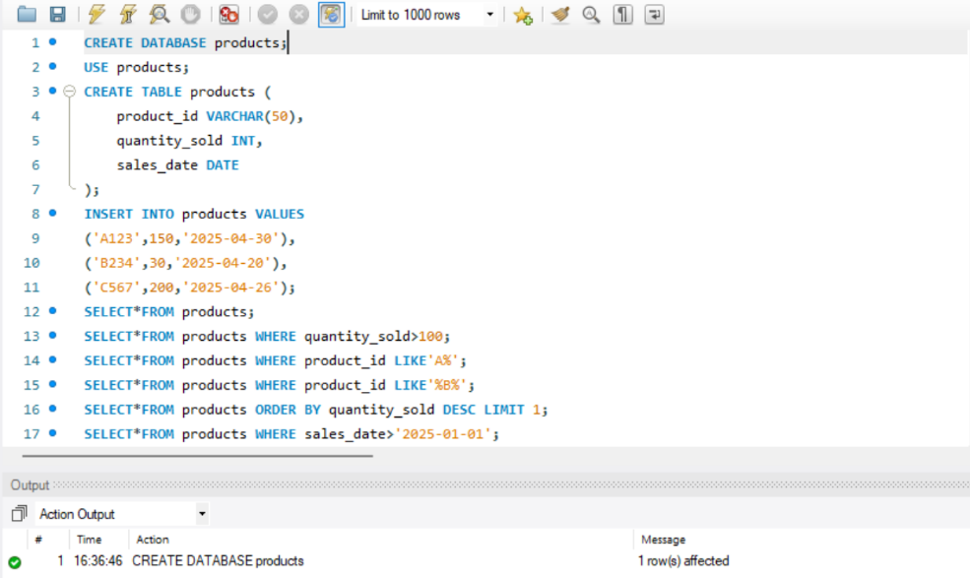

**Screenshot 2**:

Creating the table and inserting data.

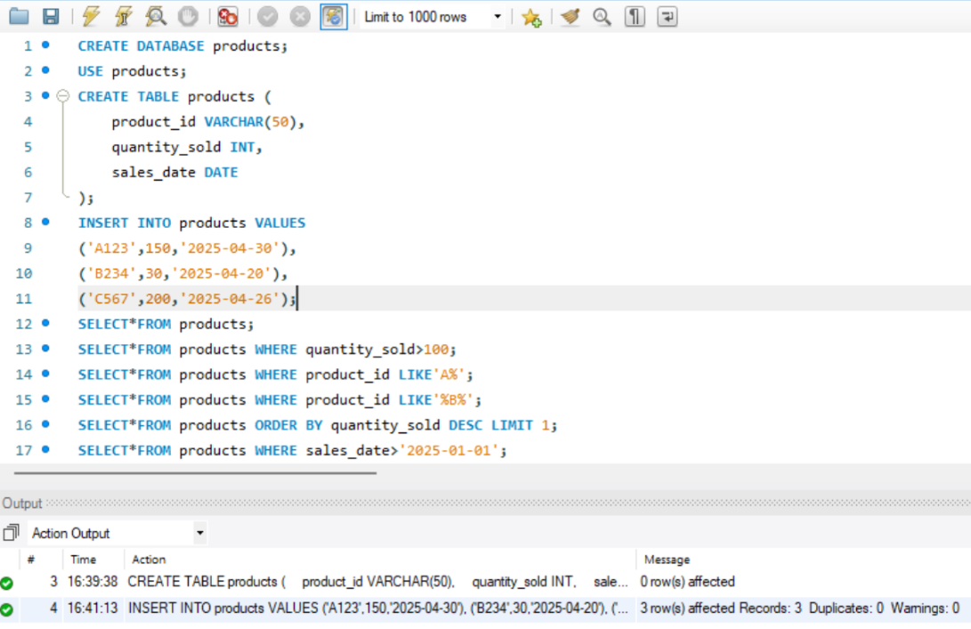

**Screenshot 3**:

Running SELECT queries.

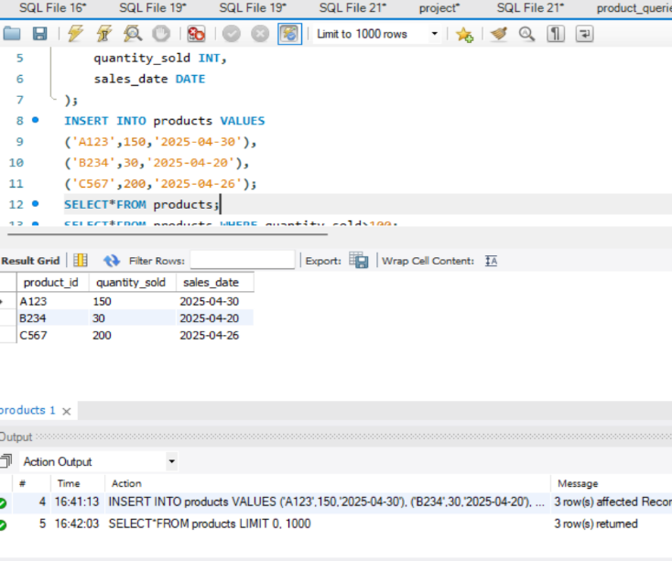

**Screenshot 4**:

Running aggregate or conditional queries.

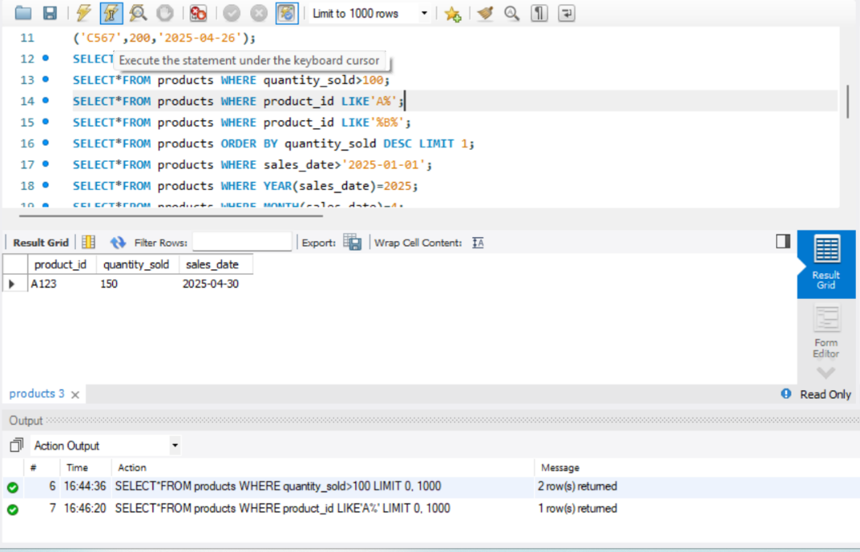

**5. Conclusion**

This project helped me learn how to create an SQL database, insert data, and run different queries to get information from the database. I used SQL to find specific products, filter data, and count the total number of products.

This project gave me practical experience with SQL queries, which are important for managing and analyzing data. In the future, I could add more tables or queries to make this project more complex, like adding customer data or product categories.